**104. Module Introduction**

* -: Welcome to a new module in this course.
* This module is about services and dependence injection.
* Now what is that? Let's start with services.
* What are services? Let's consider this application.
* We get a app component and about component and user component and a user detail component.
* Now, we might have some methods in those components.
* Let's say we want to log some data to the console the about component and user detail component and somehow this log statement is pretty similar so pretty much the same text.
* So we're basically repeating ourselves here.
* We're duplicating code in two different components.
* Let's say in the user component.
* We also want to access some data, some array of users maybe and maybe we also don't know if we will later use it in some other part of our application.
* Both use cases, duplication of code and data storage providing data, our typical use cases for a service.

**What is Service:**

* Because a *service is basically just another piece in your Angular app, another class you can add which acts as a central repository.*
* As a central business unit you could say something where you can store where you can centralize your code in.
* So we could create a log service, for example to centralize our log statement.

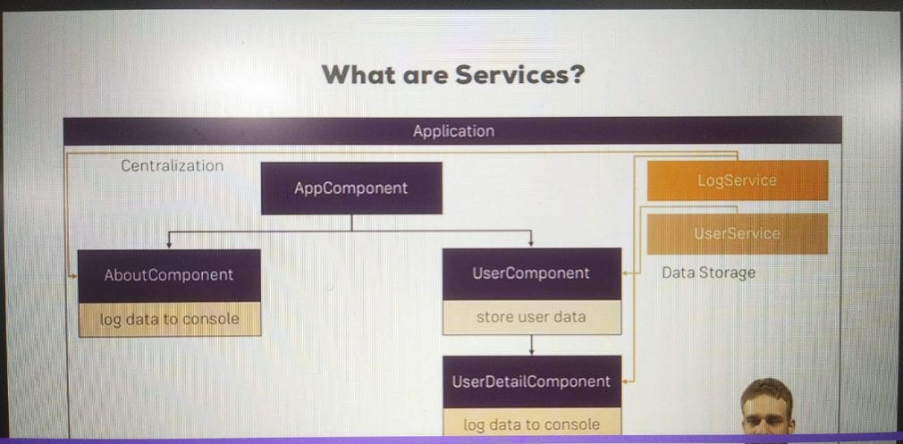

* We could create a user service to manage the data storage here.
* Let's see this in a real app so that it becomes more clear though.